CMR INSTITUTE OF TECHNOLOGY

Affiliated to Visvesvaraya Technological University(VTU) Sri Nivasa Reddy Layout, AECS Layout,
Marathahalli,Bengaluru, Karnataka 560037

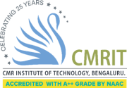

Department of Information Science and Engineering
DEVOPS LAB (BCSL657D)
Question Bank
Academic Year: 2025-26

Semester-VI Scheme-2022

Course Objectives (Defined by the university):

At the end of the course, the student will be able to :
- To introduce DevOps terminology, definition & concepts
● To understand the different Version control tools like Git, Mercurial
● To understand the concepts of Continuous Integration/ Continuous Testing/ Continuous Deployment)
● To understand Configuration management using Ansible
● Illustrate the benefits and drive the adoption of cloud-based Devops tools to solve real world problems

IAT1 QB

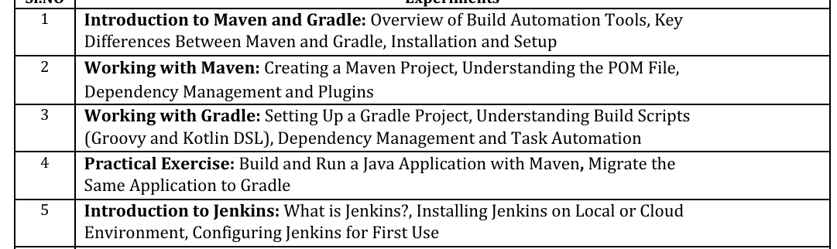

IAT2 QB

